Multiple Sequences Alignment
Abstract
This project focuses on Multiple Sequence Alignment (MSA) of hemoglobin proteins obtained from different organisms. Protein sequences were collected from the UniProt database and aligned using Clustal Omega. The alignment results identified conserved amino acid regions and sequence similarities among the proteins. The study helped in understanding evolutionary relationships and functional conservation of hemoglobin proteins across species.
Introduction
Bioinformatics is an interdisciplinary field that combines biology and computational tools to analyze biological data. Multiple Sequence Alignment (MSA) is an important technique used to compare biological sequences and identify conserved regions among proteins or DNA sequences.
In this project, hemoglobin protein sequences from different organisms were aligned using Clustal Omega. The analysis helped identify conserved amino acids and evolutionary relationships between the selected proteins.
Methods and Materials
Data Collection
Protein sequences used in this study were collected from the UniProt database, a comprehensive resource for protein sequence and functional information. Hemoglobin protein sequences from different organisms including human, mouse, and rat were selected for comparative analysis.
Sequence Retrieval
The selected protein sequences were downloaded in FASTA format from the UniProt database. FASTA format is a standard text-based format used for representing nucleotide and protein sequences in bioinformatics studies.
Multiple Sequence Alignment
The retrieved FASTA sequences were subjected to Multiple Sequence Alignment (MSA) using the Clustal Omega tool available through the European Bioinformatics Institute (EBI). The sequences were uploaded into the Clustal Omega interface and aligned using default alignment parameters.
Conserved Region Analysis
After alignment, conserved amino acid regions, sequence similarities, and variations among the proteins were analyzed. Conserved residues were identified based on alignment symbols such as asterisks (*), which indicate identical amino acids across all sequences.
Result Interpretation
The alignment results were interpreted to study evolutionary relationships and functional conservation among hemoglobin proteins from different species. The conserved regions observed in the alignment indicate structural and biological importance of the proteins.
Results
The alignment results showed several conserved amino acid residues among the hemoglobin proteins. The presence of highly conserved regions indicates structural and functional similarity across species.
The hemoglobin protein sequences from human, mouse, and rat were retrieved from the UniProt database in FASTA format for Multiple Sequence Alignment analysis.
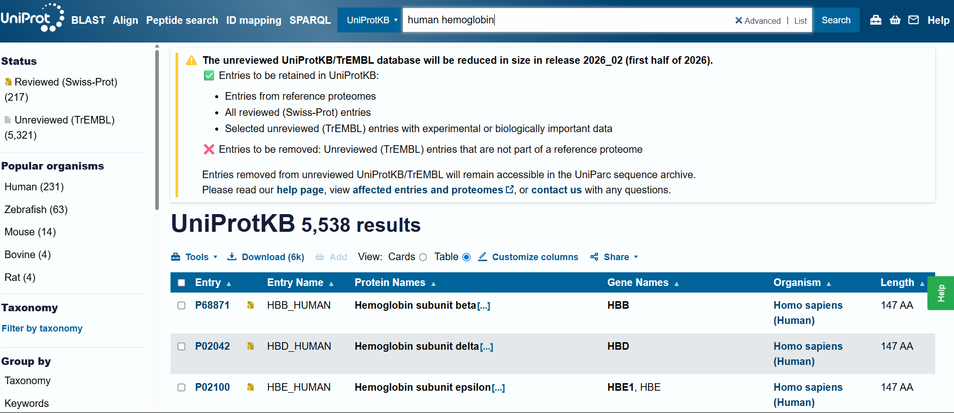
Fig1: - uniprot protein entry.

The FASTA sequences of the selected proteins were collected and prepared for alignment analysis using Clustal Omega.
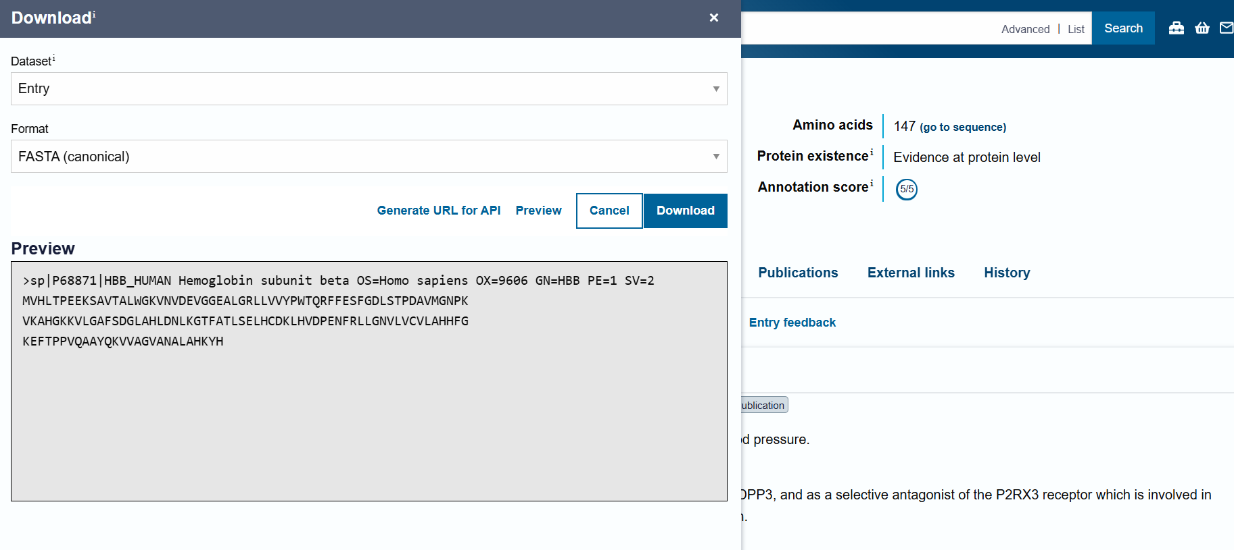
Fig2: - FASTA sequence

The collected sequences were uploaded into the Clustal Omega server and aligned using default alignment parameters.
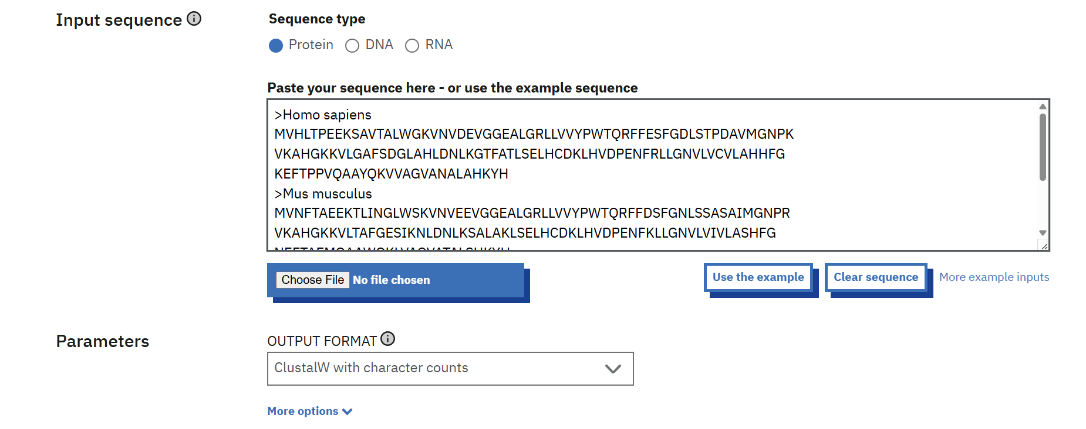
Fig3: - Clustal Omega input page showing pasted sequences
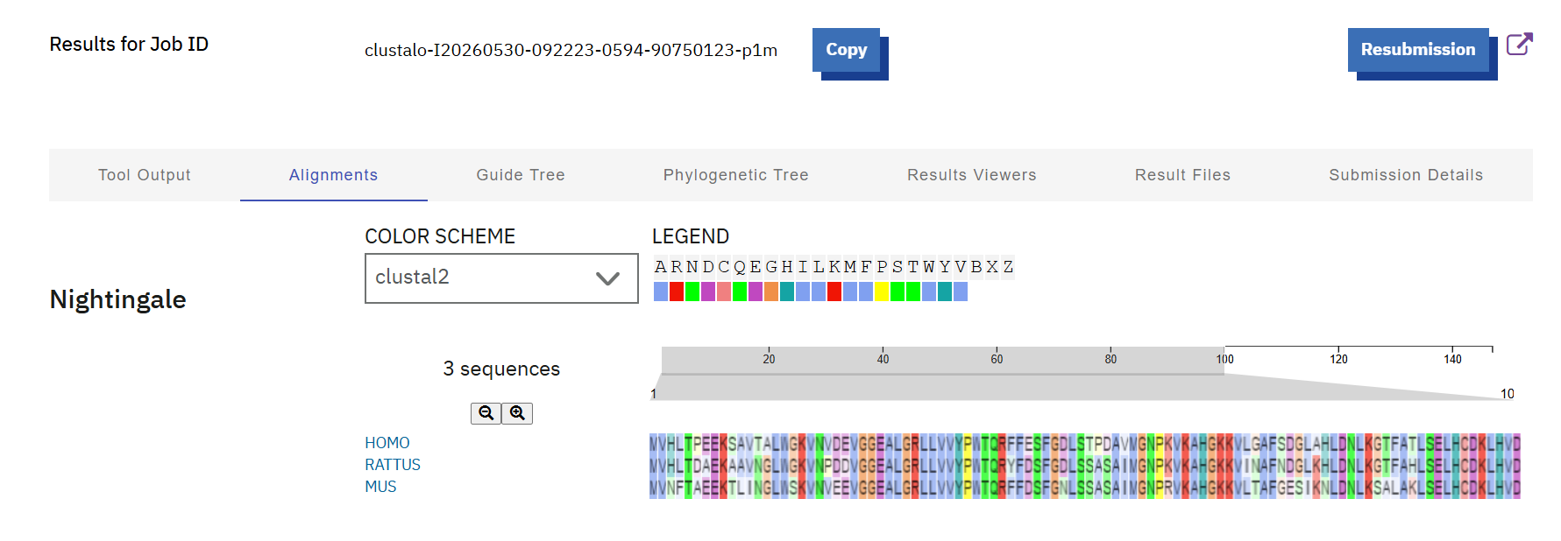
Fig4: - Alignment of the protein sequences

Conclusion
The project successfully demonstrated Multiple Sequence Alignment using Clustal Omega. Conserved amino acid regions were identified among hemoglobin proteins from different species. The study provided insights into protein evolution and functional conservation.

MULTIPLE SEQUENCES ALIGNMENT OF HEMOGLOBIN PROTEINS USING CLUSTAL OMEGA
Submitted by:
Disha Chandrakant Annapure
Internship domain:
Bioinformatics internship

